University Of Engineering and Technology, Lahore
Computer Engineering Department

Course Name: PF | Course Code: CMPE-112L
Assignment Type: Lab | Dated: 30 march 2026
Semester: 1 | Session: Spring 2026
Lab/Project/Assignment #: 1 | CLOs to be covered: CLO 2
Lab Title: Functions | Teacher Name: Hafiz Muhammad Mubashar
Lab Evaluation:

CLO1 | Apply appropriate programming techniques to create executable programs to solve well defined problems
 | Level1 | Level2 | Level3 | Level4 | Level5 | Level6
(5)
Total |  |  |  |  |  | /5
Rubrics for Current Lab Evaluation
Scale | Marks | Level | Rubric
Excellent | 5 | L1 | Submitted all lab tasks, BONUS task, have good understanding.
Very Good | 4 | L2 | Submitted the lab tasks but have good understanding
Good | 3 | L3 | Submitted the lab tasks but have weak understanding.
Basic | 2 | L4 | Submitted the lab tasks but have no understanding.
Barely Acceptable | 1 | L5 | Submitted only one lab task.
Not Acceptable | 0 | L6 | Did not attempt
LAB No 5
Lab Goals/Objectives:
• Understand the concept of functions in Python.
• Learn how to create and call functions.
• Understand parameters and return values.
• Improve code organization and reusability.

Equipment Required:
• Computer/Laptop
• Python IDE
• Python Interpreter

Theory:
A function is a separate section of a program that is written to complete a particular job. Instead of writing the same instructions multiple times, a function can be called whenever that task needs to be performed.
Using functions provides several advantages:
- They keep the program organized and easier to understand.
- They avoid writing duplicate code.
- They simplify testing, updating, and fixing programs.
A function may:
- Accept values from the user or another part of the program through parameters.
- Process those values to perform a specific task.
- Send the final result back to the program using a return statement.
In Python, a function is defined by using the def keyword followed by the function name and its parameters.

Lab Work
Task 1
Write a python program with functions to calculate Factorial, Permutation and Combinations.

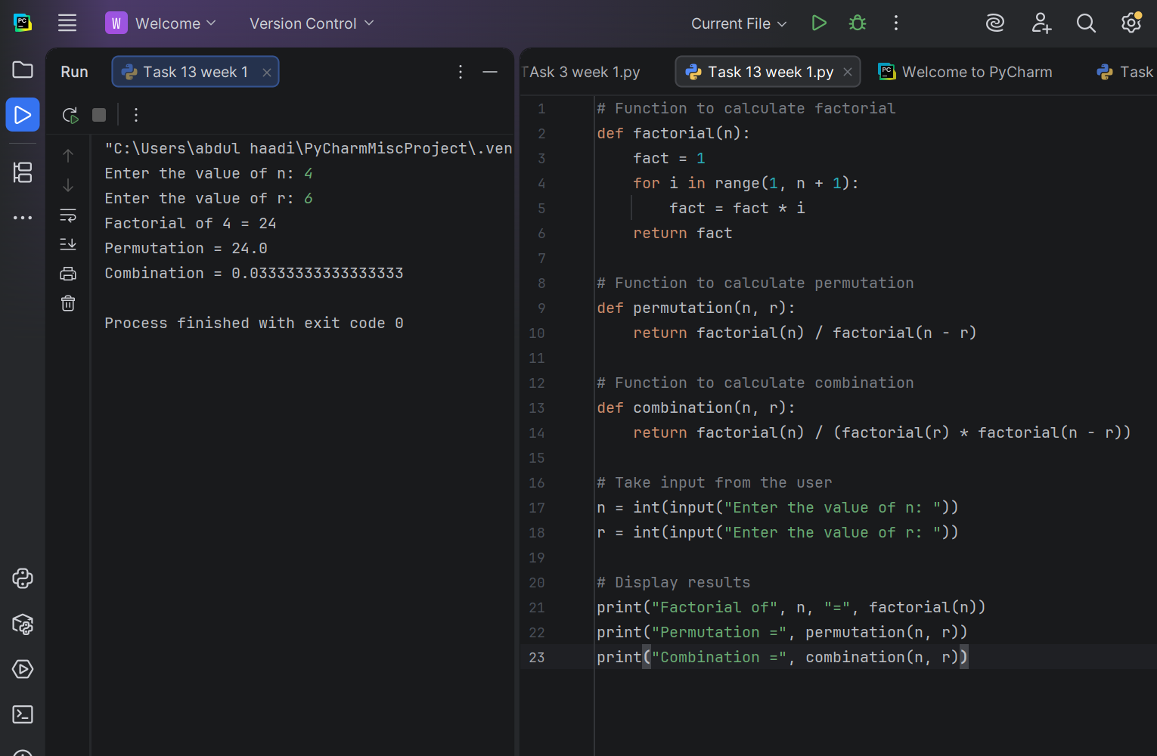

Task 2
Write a python program that uses a lambda function and a regular function to find the larger of two numbers and print its multiplication table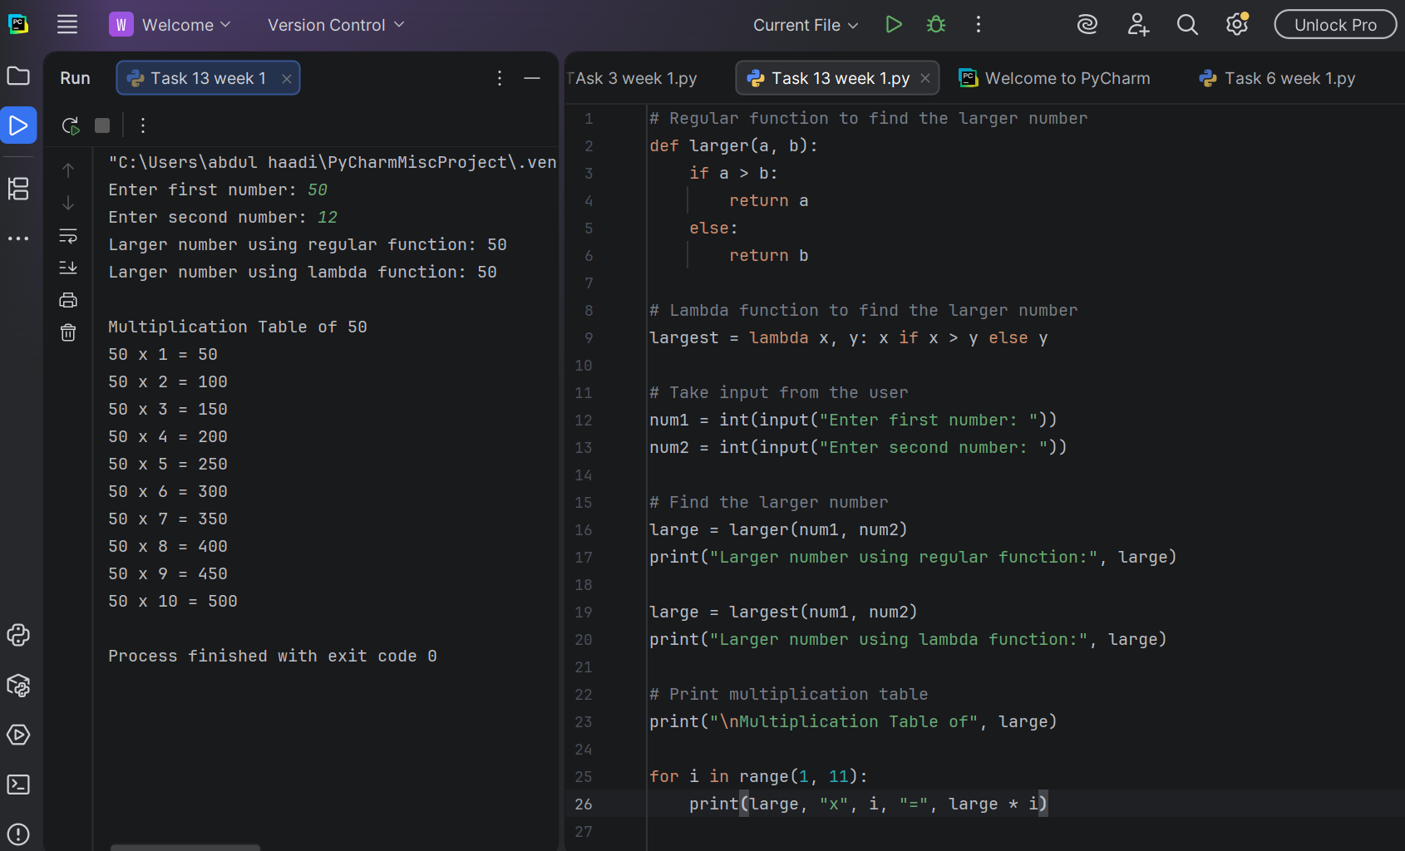

Task 3
Write a python program that uses a lambda function and a normal function to process a string.
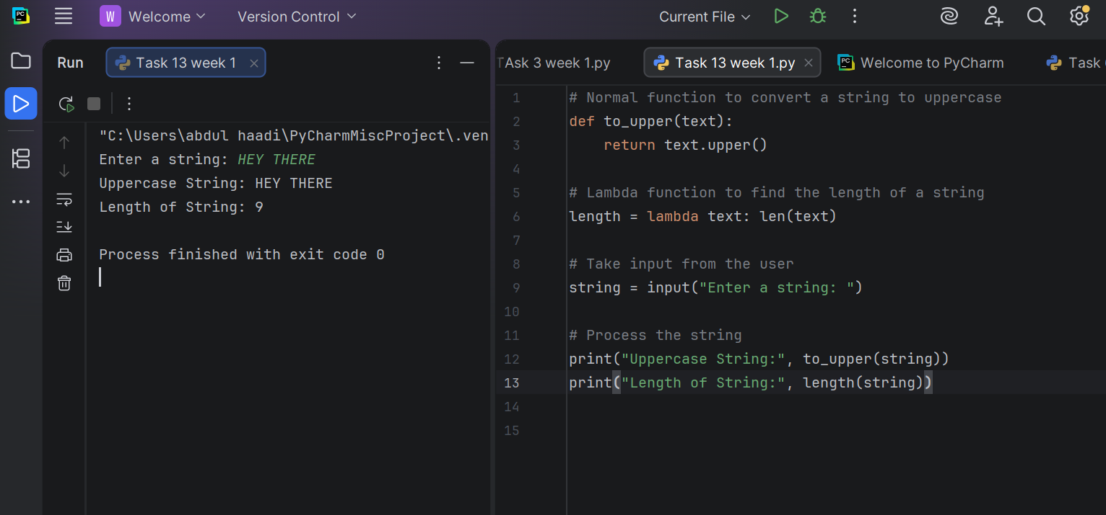
Task 4
Write a python program to calculate a student’s GPA .

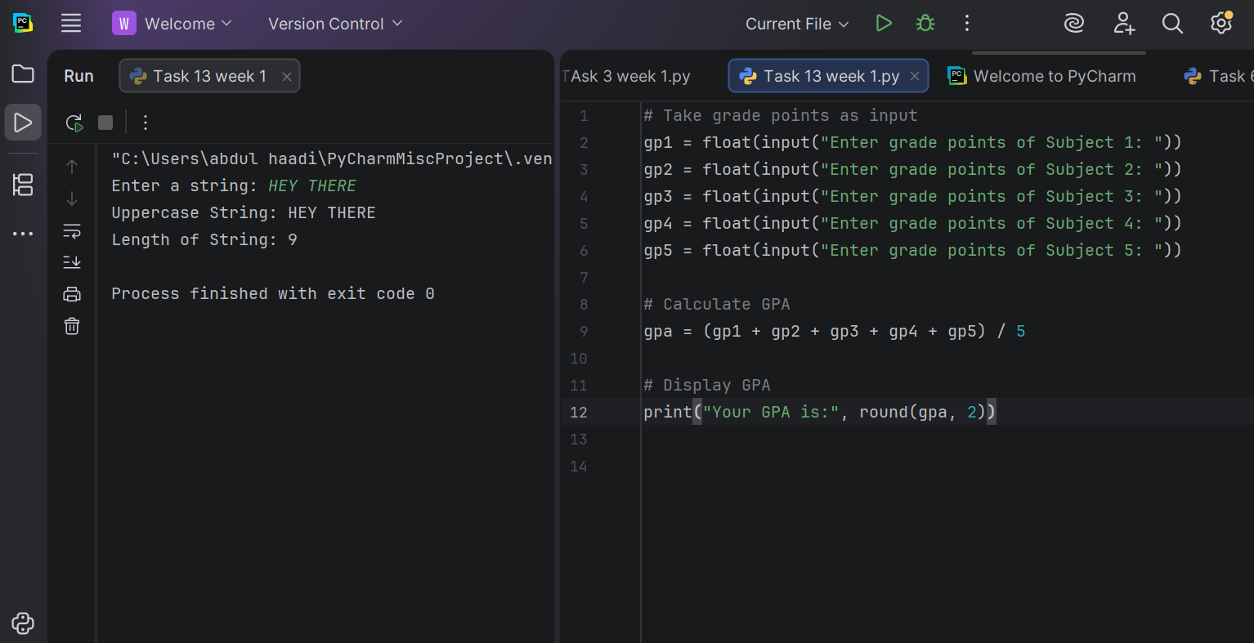

Task 5
Write a python function that defines a function to add two numbers and tests it with different inputs.
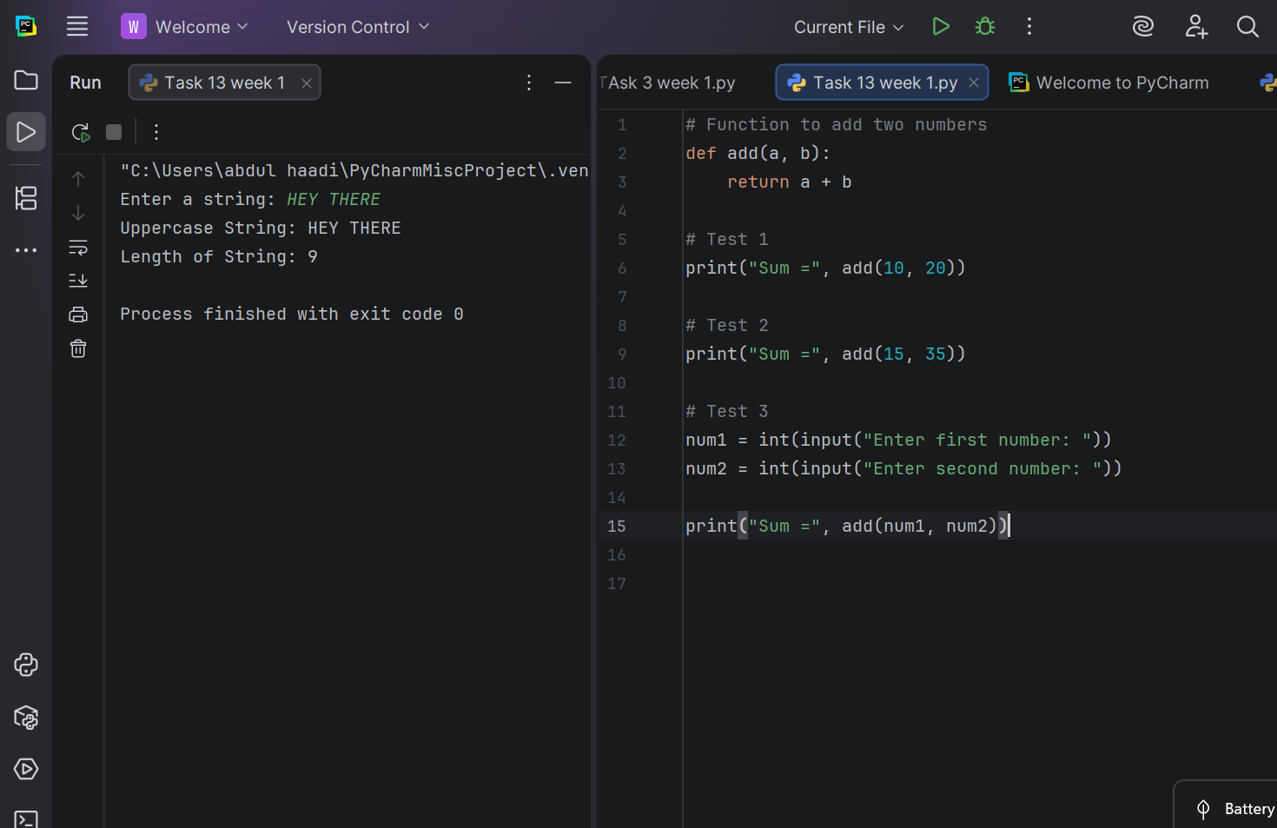

Task 6
Write a python program to demonstrate function definition and reuse by printing text multiple times.

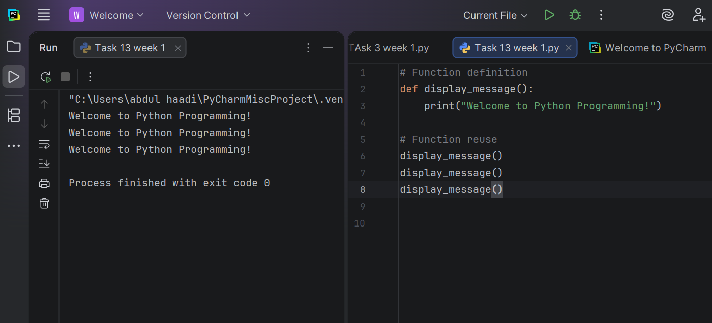

Conclusion

In this lab, we explored how functions are used in Python and why they are an important part of programming. We learned that functions help break a program into smaller, organized parts, making the code simpler to read, debug, and maintain.
We practiced defining functions with the def keyword, passing information through parameters, and returning values using the return statement. We also saw how functions eliminate the need to write the same code repeatedly, resulting in cleaner and more efficient programs.
Overall, this lab strengthened our understanding of modular programming and demonstrated how reusable functions improve code organization and make program development more effective. Learning to use functions is a fundamental step toward writing well-structured Python applications.

